GitHub Tasks.
- Create a GitHub account.
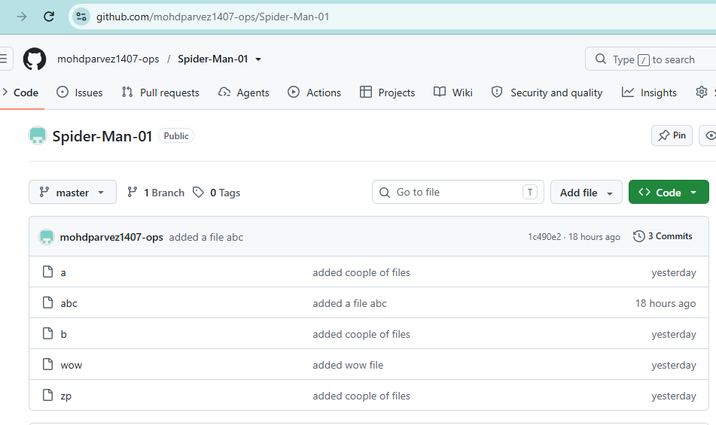
- Set up MFA (Multi-Factor Authentication) for the GitHub account using a mobile app.
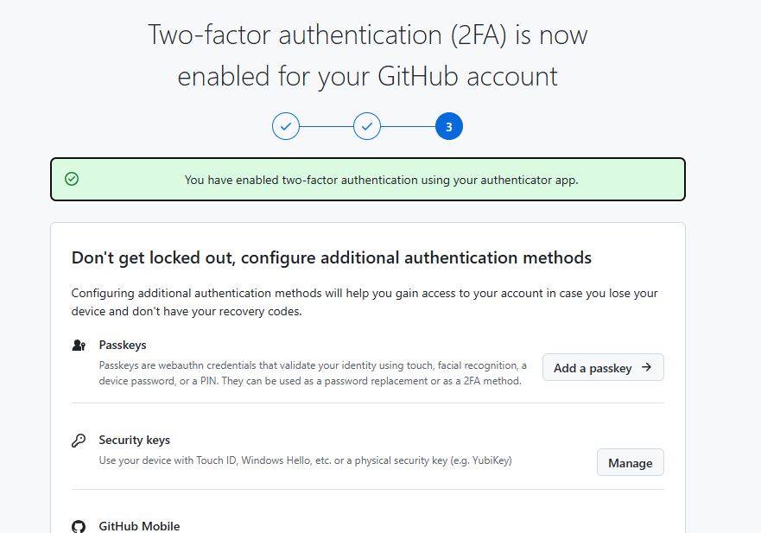
. 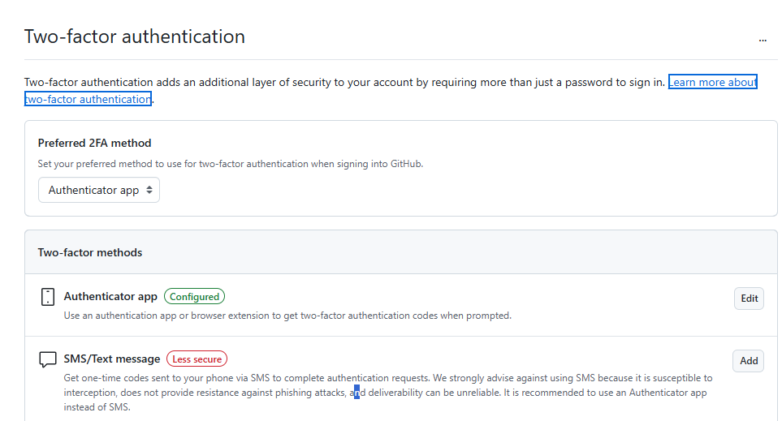
- Execute all commands shown in the video.

1.Checks the installed Git version.
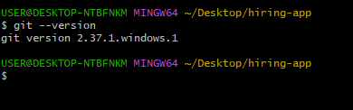
2. git status → Checks the current working directory and staging area status.
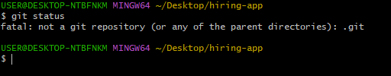
- Initializes a Git repository in the current directory.
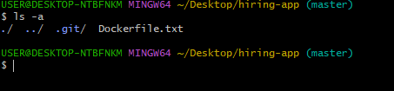
5. git config -l → Displays all Git configuration settings. 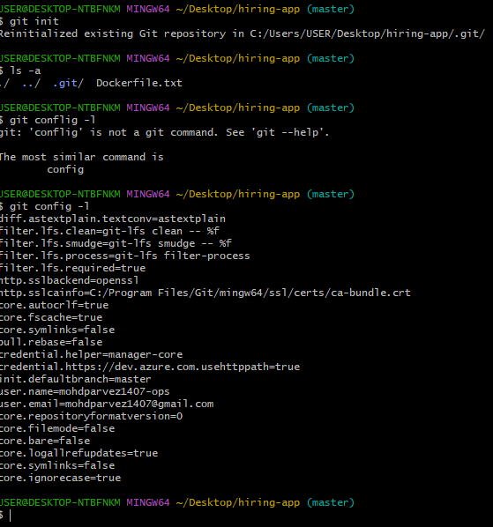
6. git config --global user.name "Your Name" → Sets your Git username globally.
7. git config --global user.email your@email.com
8. git add → Stages files for commit.
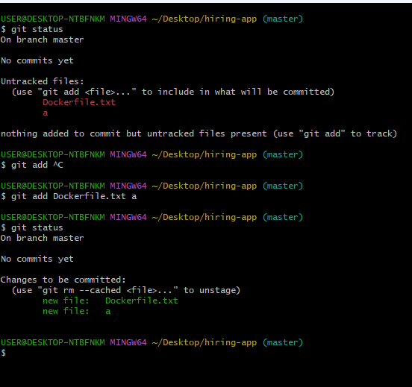
9. git reset → Unstages changes from the staging area.
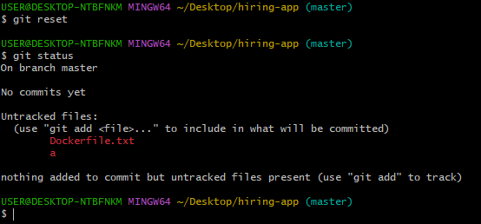
10. git commit -m "message" → Creates a commit with a message.
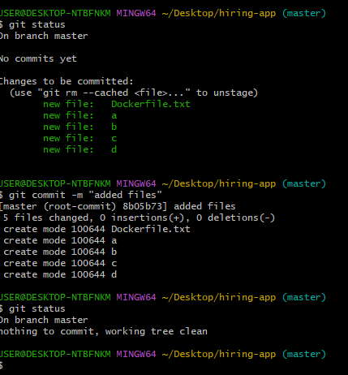
11. git log → Displays the commit history.
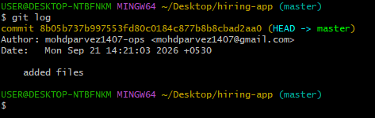
12. git push -u origin master → Pushes master to GitHub.
13. git remote add origin <URL> → Adds a GitHub remote repository named origin.
14.git remote

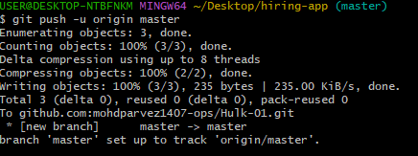
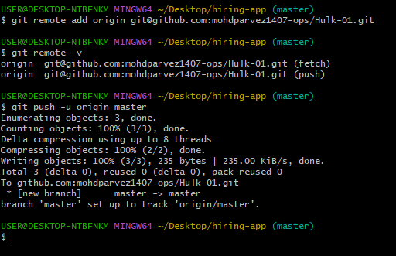
15.git pull → Gets the latest changes from the remote repository.
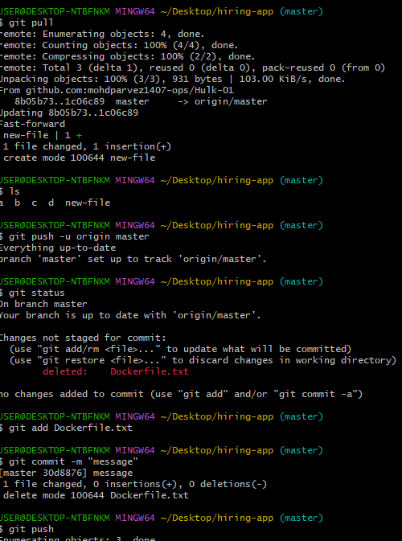
16. git clone → Copies a remote Git repository to your local system.
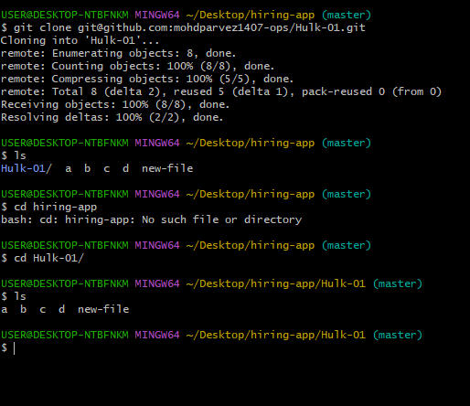
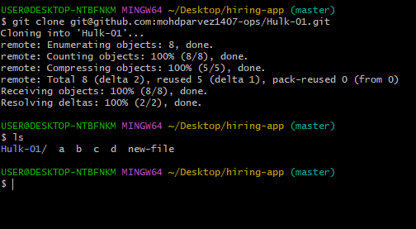
17. git revert → Undoes a commit by creating a new commit.

